**Running multiple instances of Lync 2010 or Office Communicator 2007 R2**

1. First open 1 instance of your communicator (Either Lync 2010 or Office Communicator R2) with CTS or Comcast login.
2. Now open the below attached ProcessExplorer application.



1. This will open the Process Explorer application with the following window.

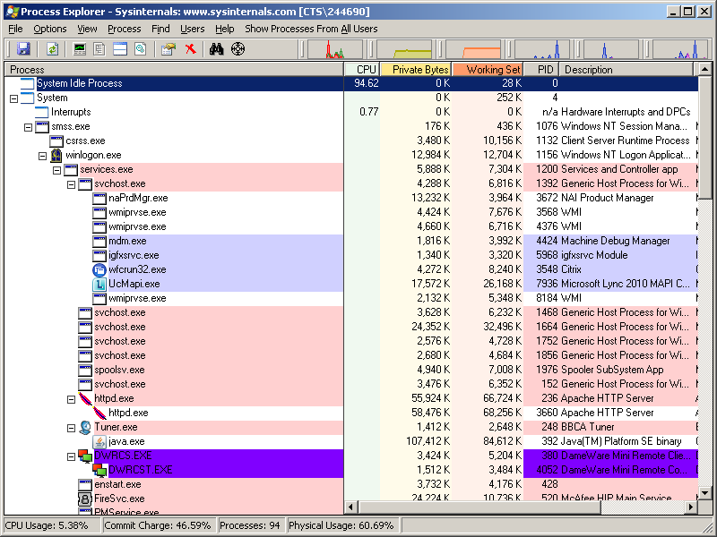

1. Go to View menu and Click the “Show Lower Pane” option.

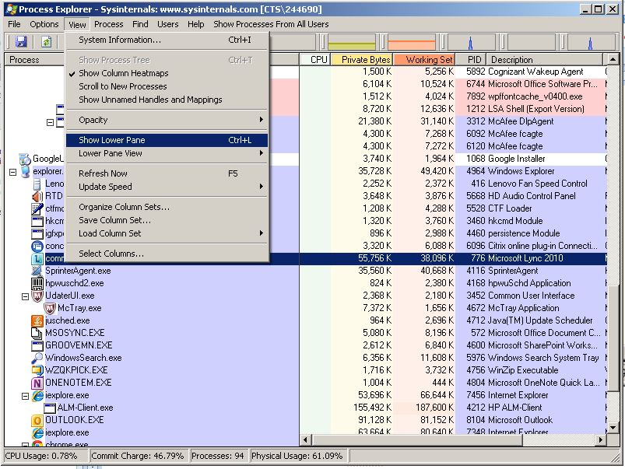

1. Scroll down the left hand pane and look for the process **“Communicator.exe”** and select that [The process name is the same for both Lync and Office Communicator]
2. Look in the Lower Pane for an entry of the **“Event”** type with the name **“\BaseNamedObjects\COMMUNICATOR-”**. Right Click on it and select **“Close handle”.**

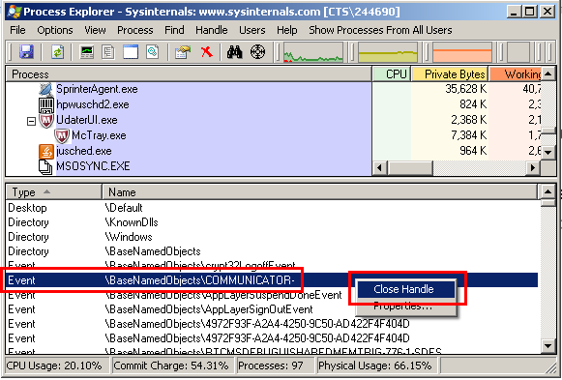

1. Now look in the Lower Pane for an entry of the **“Mutant”** type with the name **“\BaseNamedObjects\Office Communicator_{4a0e5ea9-202e-4a3a-ac0e-f6e2b03b745d}”**. Right Click on it and select **“Close handle”.**

**[Note: The value highlighted in green above will vary every time Communicator is invoked]**

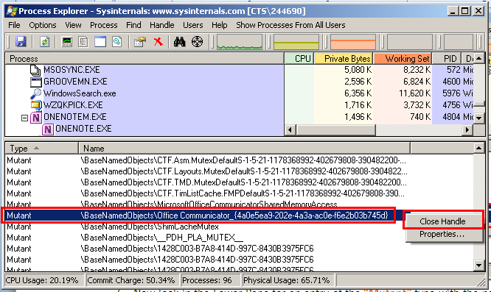

1. You can now close Process Explorer. You have successfully duped Lync/Office Communicator into thinking that it is not running even though the process is running. ☺
2. Open another Lync or Communicator instance by going to Start 🡪 All Programs 🡪 “Microsoft Lync 2010” / Start 🡪 All Programs 🡪 “Microsoft Office Communicator 2007 R2” based on the one that is installed on your machine.
3. This open another communicator instance on your machine and it will try logging in with the same login as the already running instance.

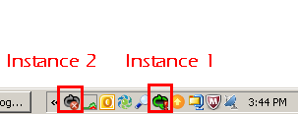

1. Double Click the 2nd instance and Stop it from signing in. (This is because you cannot login to the same account (CTS&CTS or Comcast&Comcast) twice. Now login to the other account using that Email ID as the Sign-In address.

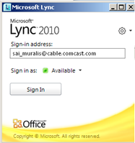

1. After logging in, you will now have both Comcast and CTS communicators usable simultaneously. ☺ 

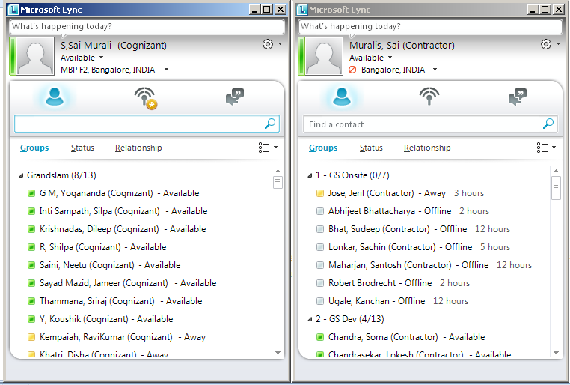

**Note: You will need to perform this activity every time you restart your PC. Also, I’ve seen this method working only for Microsoft Lync 2010 and Microsoft Office Communicator 2007 R2 editions.  
Caution: Force closing Event Handles and Mutants may cause system instability, but I have not noticed anything alarming till date.**